Module 7

Robertson, Rashai

Bellevue University, CSD325

Assignment 7.2

04/20/2025

city_functions.py:

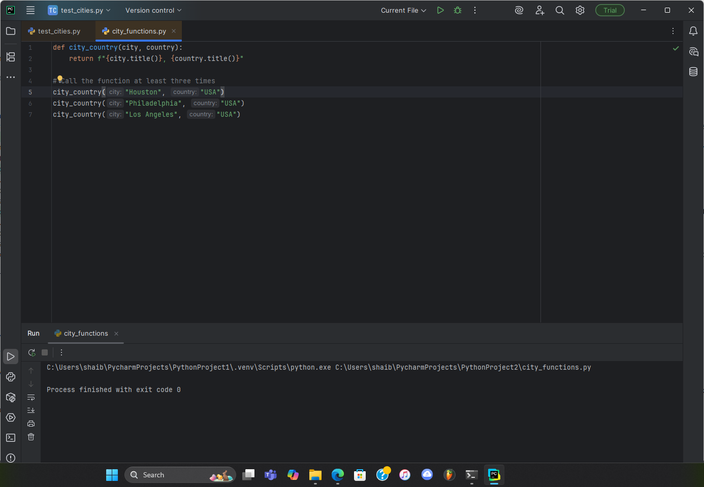

1st Test - Pass: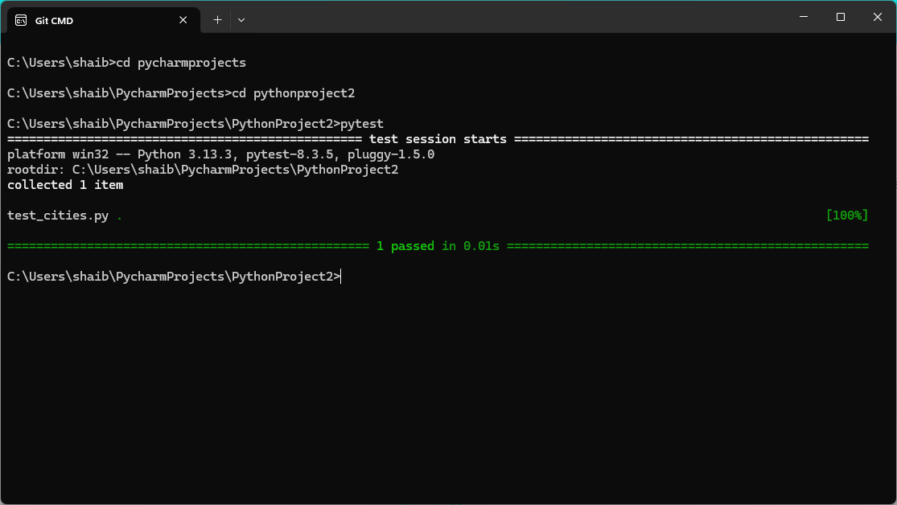

2nd Test - Fail:

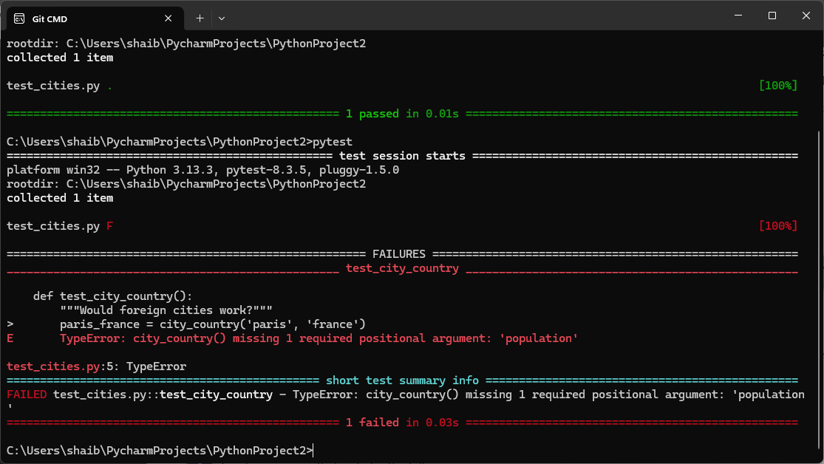

3rd Test - Pass:

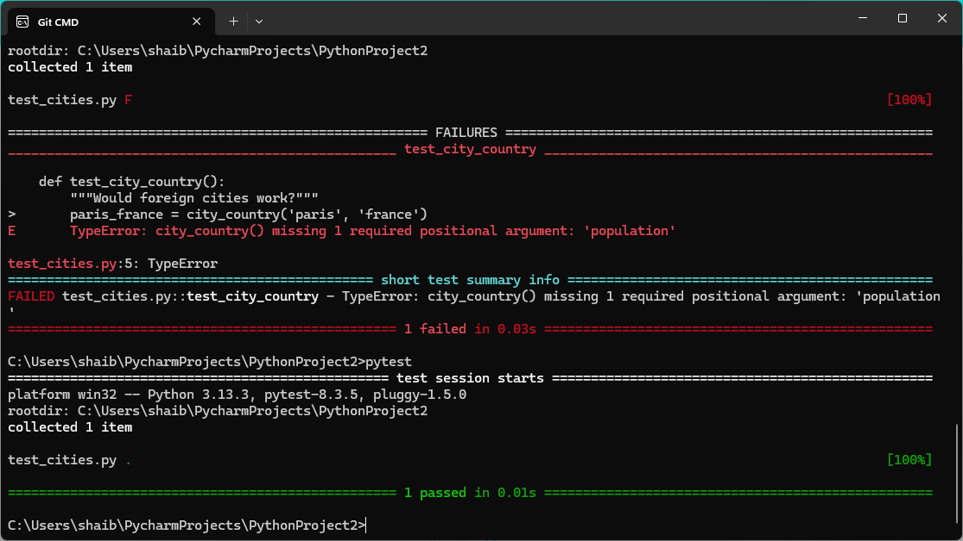

4th Test – Fail:

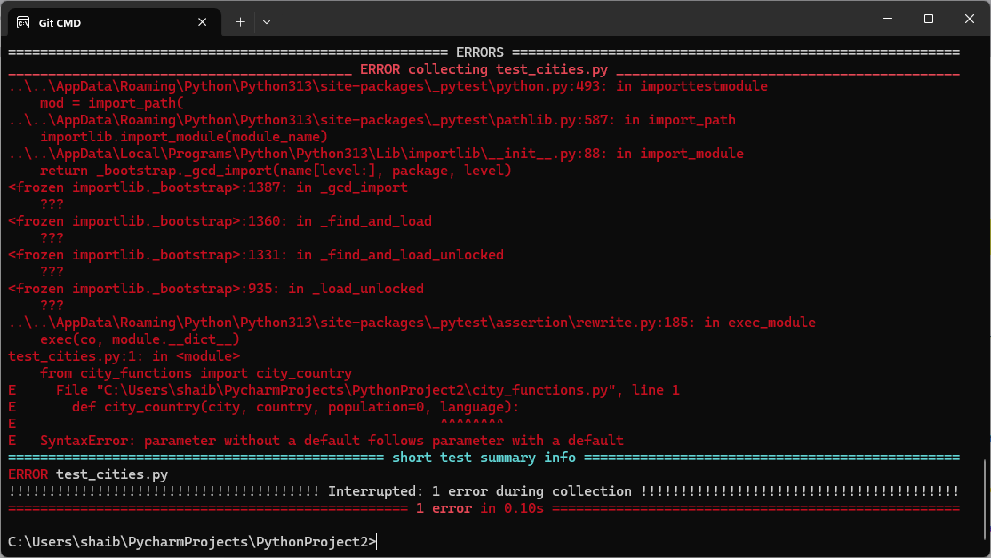

5th Test – Pass:

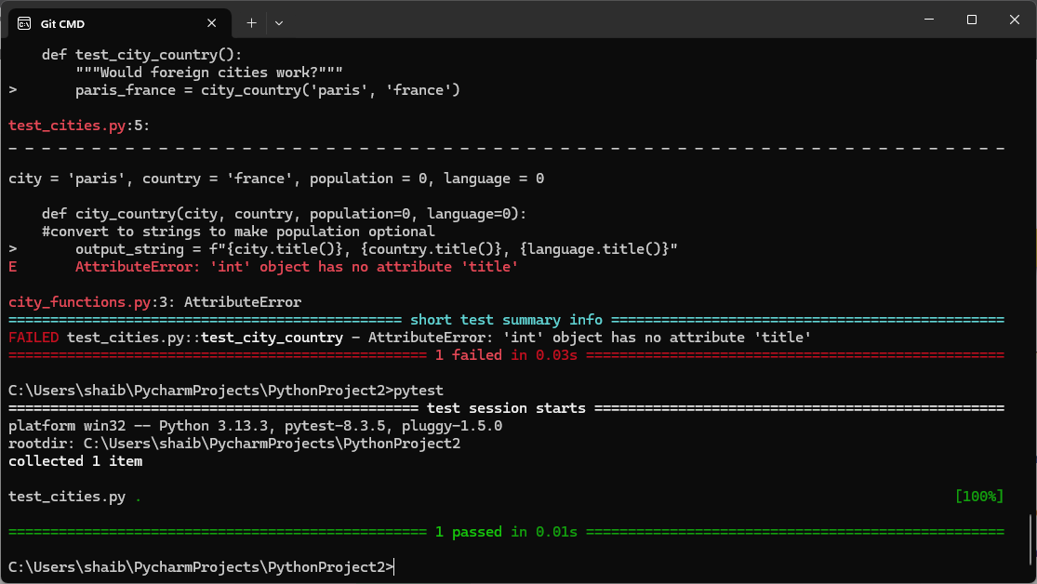

Final Execution:

